NAME:IMMACULATE AWUOR
ADM NUMBER:BBIT/2024/56947
COURSE:BUSINESS INFORMATION TECHNOLOGY
UIT CODE:BIT3208 UNIT NAME:ADVANCED WEB DESIGN AND DEVELOPMENT
LECTURER NAME:NYORO
SEMESTER:MAY-AUGUST

PROJECT TITLE
E-commerce
Selected technology :XAMPP
CANVA
VISUAL STUDIO
Github Link: https://github.com/georgeimmaculate050-eng/E-commerce-project.git

Contents
PROJECT TITLE 1
WEEK 2:WIREFRAME AND GUI DESIGN 6
TITLE 6
WEEK 3:JAVASCRIPT AND PHP BASICS 11
TITLE:FRONTEND INTERACTION AND BACKBEND FOUNDATIONS 11
WEEK 4:SERVER SIDE COMPONENTS AND BACKBEND DEVELOPMENT FOUNDATIONS 15
WEEK 5:DATABASE COMPONENTS AND CRUD OPERATIONS 19
TASK 1:INTRODUCTION TO DATABASE 19
TASK 2:DATABASE CREATION 19
TASK 3:CREATING TABLES 19
TASK 4:CRUD OPERATIONS 20
PHP FORM DATA INSERTION IN MYSQL DATABASE 21
TASK 5:CONNECTING PHP TO DATABASE 22
TASK 6:FETCHING DATABASE RECORDS 23
GITHUB UPDATE 24

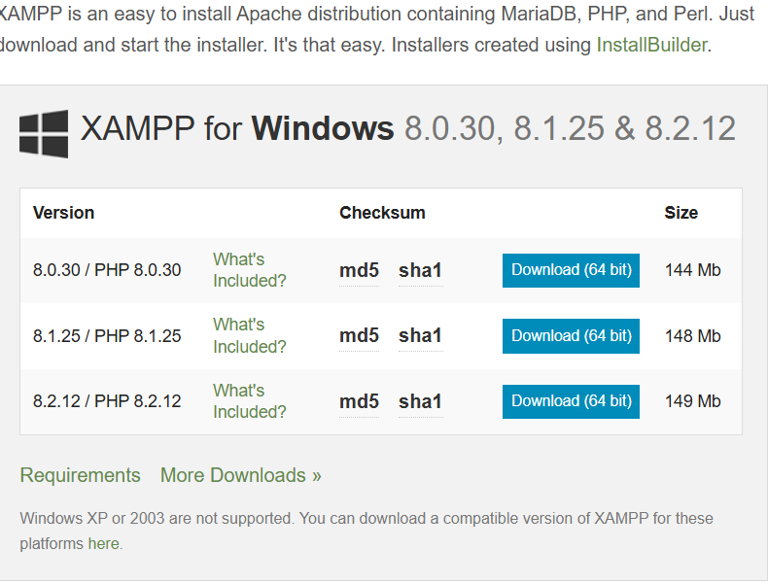
Figure 1: SETTING LOCAL ENVIRONMENT
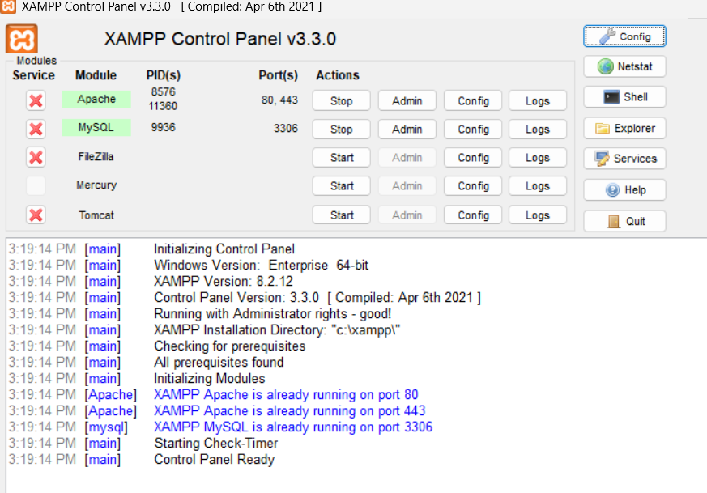
Figure 2: MySQL and Apache running

This screenshot shows local host running in my browser.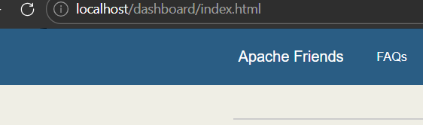
Figure 3: Local host running


Figure 4: Hello word test
This figure shows successful PHP page created for the e-commerce project. It confirms that the PHP environment is correctly configured and running on the local server through XAMPP.

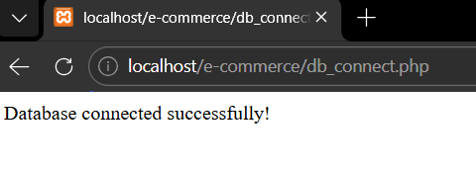
Figure 5: DATABASE CONNECTION TEST
It shows a successful connection between PHP and MySQL using mysqli_connect.

WEEK 2:WIREFRAME AND GUI DESIGN

TITLE
USER INTERFACE AND PLANNING DESIGN
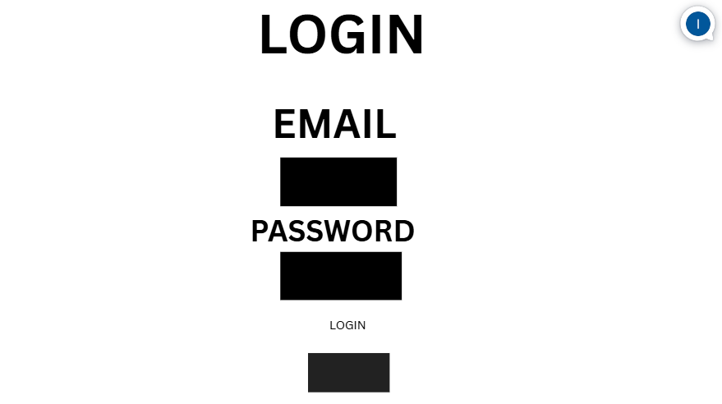
Figure 6: LOGIN/HOMEPAGE WIREFRAME
This figure shows the login page wireframe used for user authentication. It contains email and password input fields and a login button
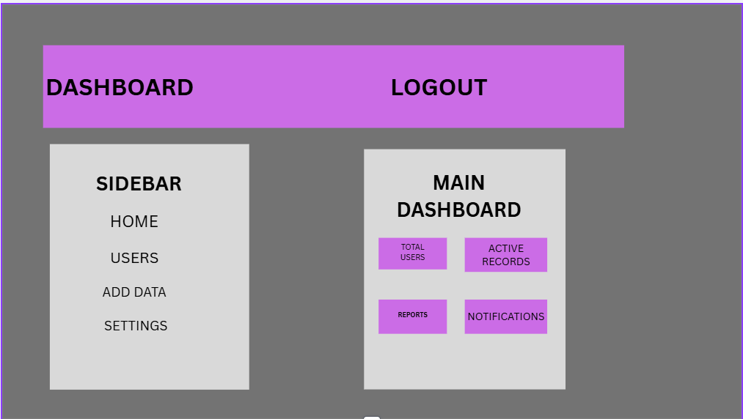
Figure 7: DASHBOARD LAYOUT DESIGN

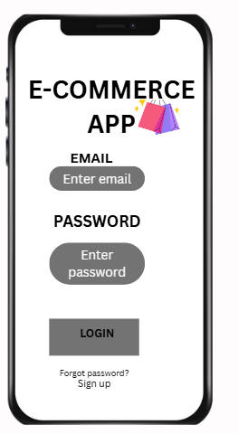
Figure 8MOBILE VIEW MOCKUP

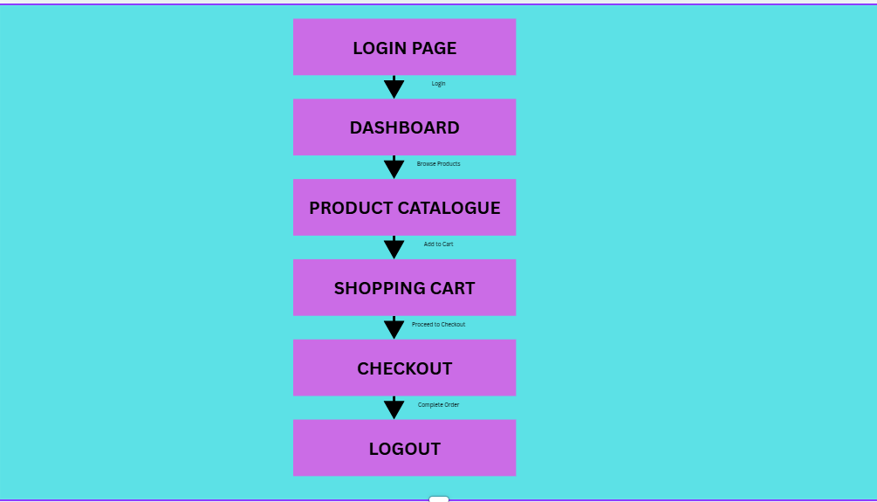
FIG 4:NAVIGATION STRUCTURE

FIG 5:GUI PROTOTYPE

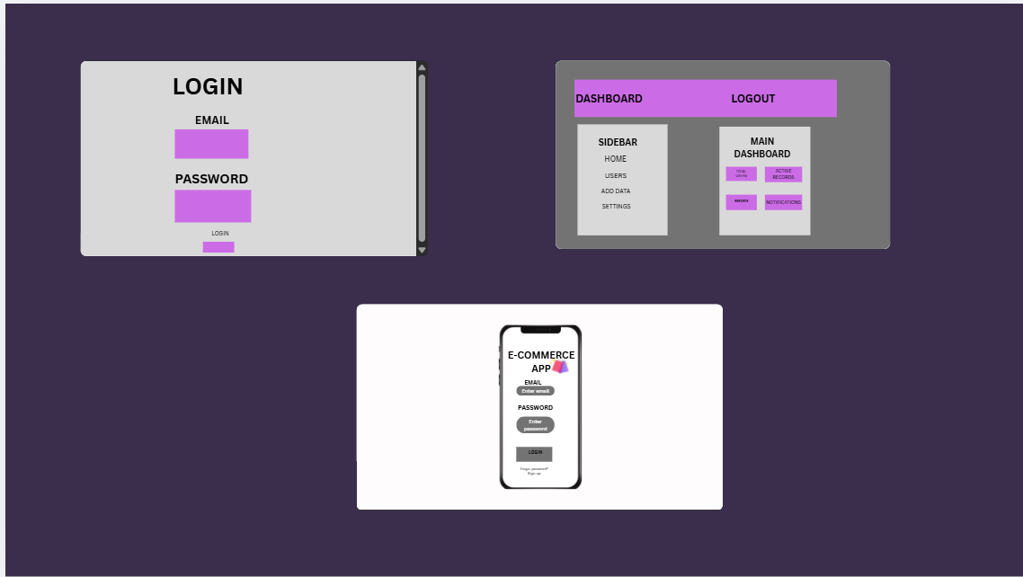

This screenshot presents the overall visual design of the e-commerce system. It combines the main interfaces of the system including the login screen, dashboard and mobile mockup.

WEEK 3:JAVASCRIPT AND PHP BASICS

TITLE:FRONTEND INTERACTION AND BACKBEND FOUNDATIONS
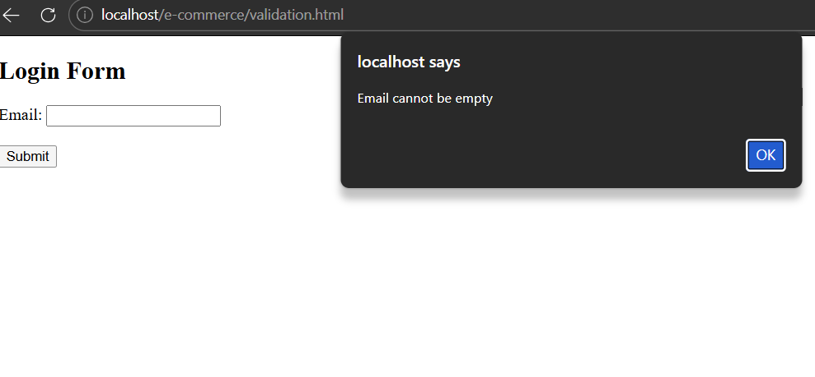

FIG 2:PASSWORD STRENGTH CHECKER
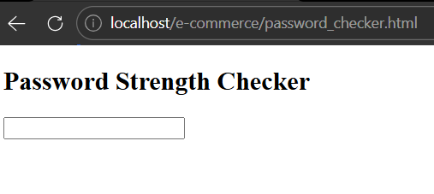
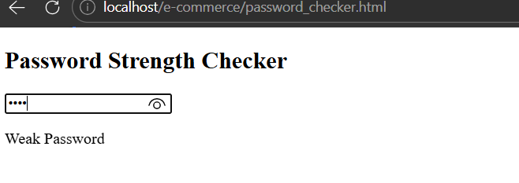
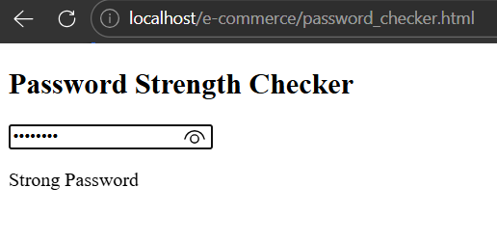

FIG 3:PHP SYNTAX PRACTICE
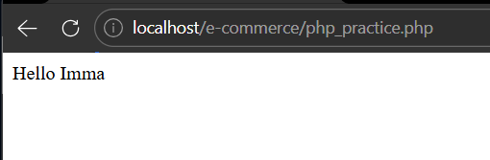

FIG 4:DATABASE CONNECTION SCRIPT
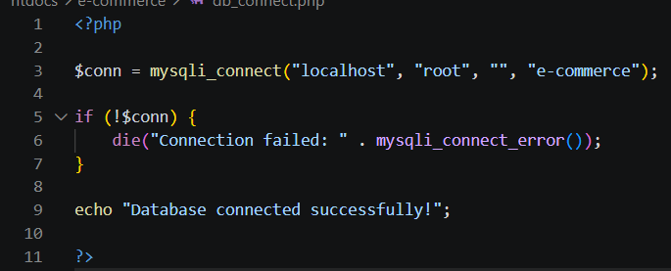


FIG 5:DYNAMIC USER INPUT HANDLING
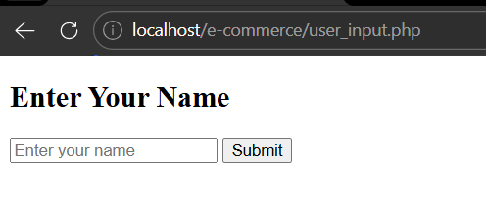

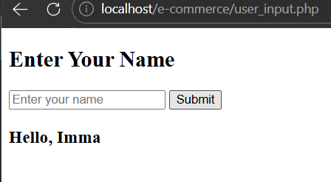

WEEK 4:SERVER SIDE COMPONENTS AND BACKBEND DEVELOPMENT FOUNDATIONS
FIG 1:REGISTRATION FORM
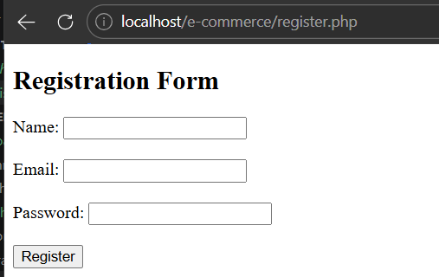
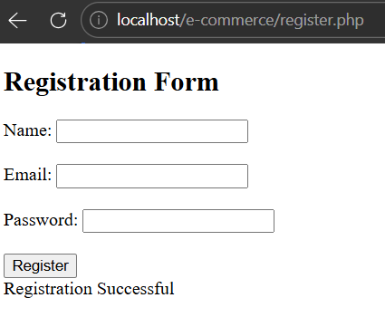

FIG 2:LOGIN FORM
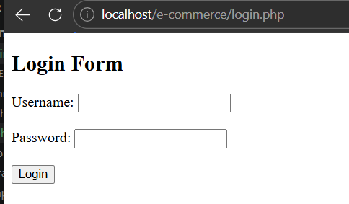
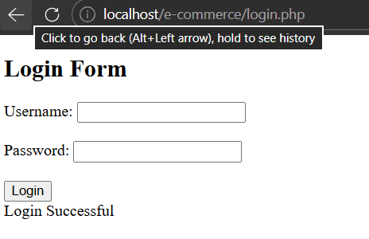

FIG 3:CONTACT FORM
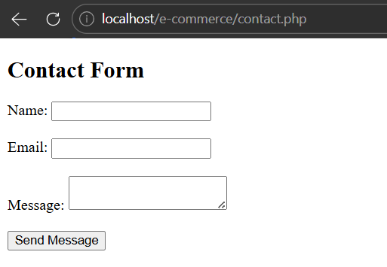
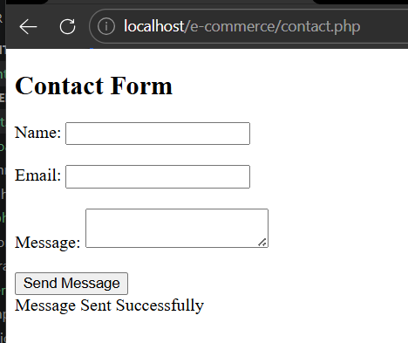

FIG 4:SESSION- BASED DASHBOARD
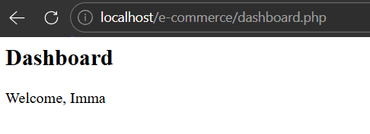

FIG 5:BACKBEND FOLDER STRUCTURE
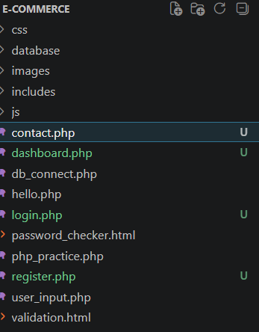
This screenshot shows a professional backbend project folder structure which shows organized separation of files, folders and resources.

WEEK 5:DATABASE COMPONENTS AND CRUD OPERATIONS

TASK 1:INTRODUCTION TO DATABASE
In this section I got to learn what database is and its importance. I also got knowledge o types of databases that is relational and NoSQL; SQL Server and Couch Db.

TASK 2:DATABASE CREATION

I created a database called E-commerce.
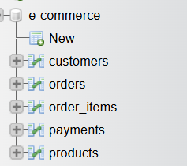

TASK 3:CREATING TABLES
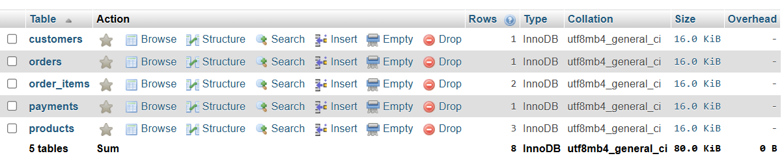
This screenshot shows the tables created under E-commerce database
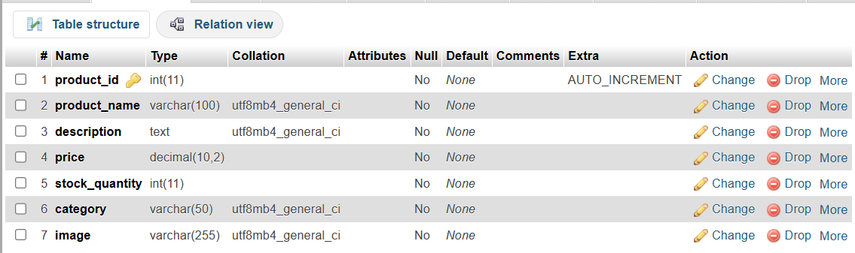
This screenshot shows the structure of the products table

TASK 4:CRUD OPERATIONS
This means: create,read,update and delete tables in a database.
i)CREATE
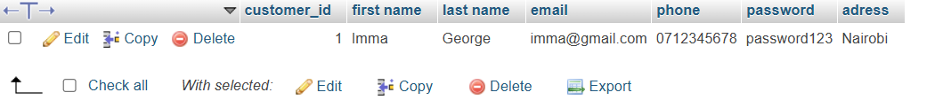
ii)READ
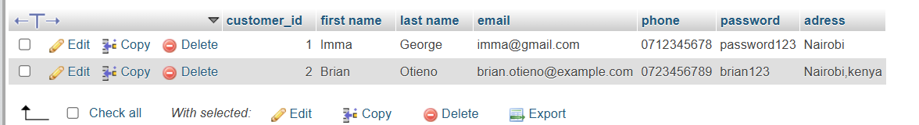
iii)UPDATE
I edited Brian’s address from Nairobi to Mombasa.
iv)DELETE

PHP FORM DATA INSERTION IN MYSQL DATABASE
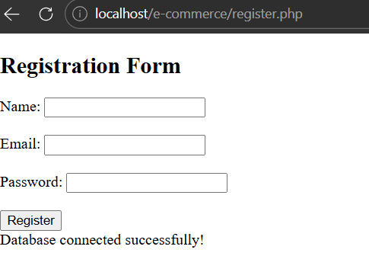

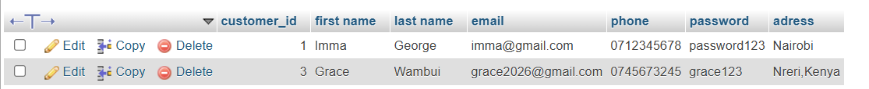

TASK 5:CONNECTING PHP TO DATABASE

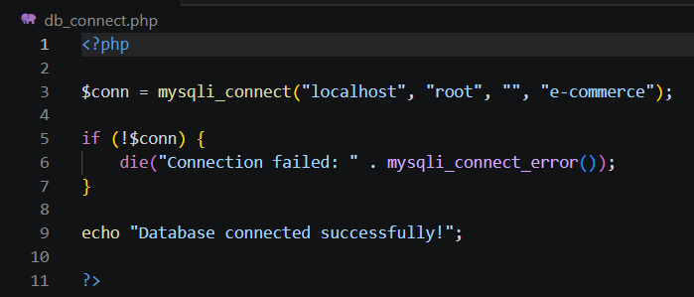


TASK 6:FETCHING DATABASE RECORDS
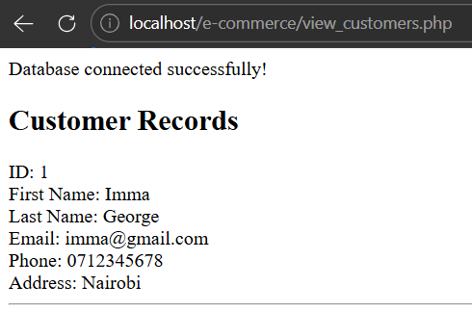

GITHUB UPDATE
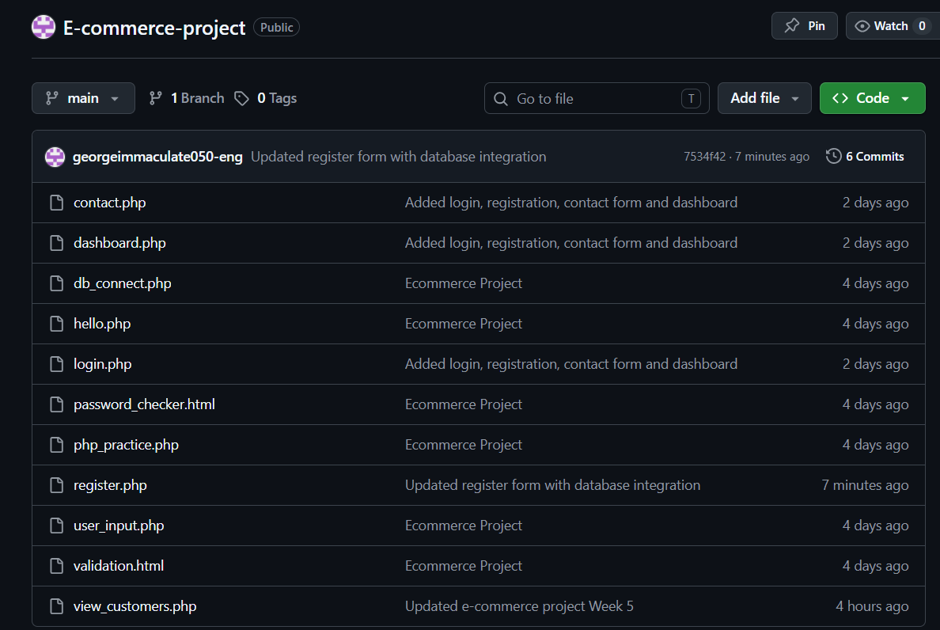
This screenshot shows screenshot shows all my source code updated from week 1 to 4.

